2014 PHENOM 300
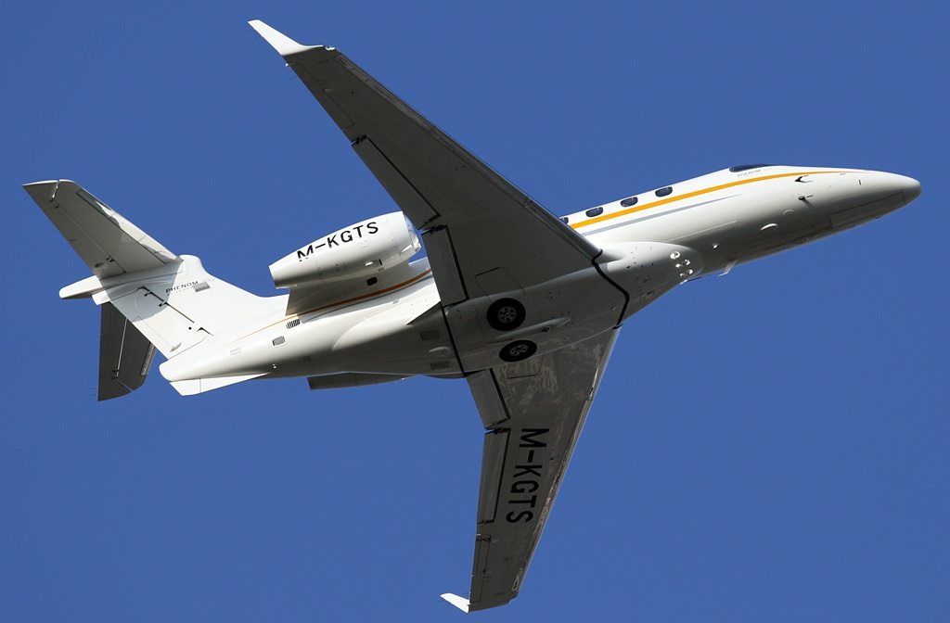
Year of Manufacture & Delivery | 2014
Manufacturer | Embraer
Model | Phenom 300
Registration | M-KGTS
Serial Number | 50500206
Location | Europe
Price | Make Offer
Total Time | 830 hrs
General Information
Low Time, EASA certified, FAA and TC compliant | RVSM
Dual Flight Directors | Aural Warning
ADSB Out | Central Maintenance Computer (CMC)
WAAS / LPV and VNAV Moving Map- RNP 1 | Single Point Refueling
TAWS-A | 7th Seat
TCAS II 7.1 | Interior/Paint like in New Condition
Times as of January 31st, 2020
Airframe
830 hrs and 594 Landings on CAMP
Engines 1 & 2
Pratt & Whitney Canada - PW535E Dual FADEC
PCE-DG0387: 830 hrs Since New, 594 Cycles
PCE-DG0389: 830 hrs Since New, 594 Cycles
TBO 5,000 hrs, HSI 2,500 hrs
Avionics
Garmin Prodigy G1000 Flight Deck
Garmin 3-Tube 12.4” Displays w/EICAS
Integrated Electronic Standby Instrument (IESI)
Dual Flight Directors
Flight Management System (FMS) including
FMS Radio Tuning Keyboard
GRS 77 Attitude and Heading Reference System
GWX 68 Weather Radar
GEA 71 – Engine Airframe Interface Unit
GSD 41 Data Concentrator Unit
GDL 69A Satellite Weather and Radio Receiver
Satellite Based Positioning Navigation (GPS – WAAS)
Vertical Navigation VNAV Moving Map and RNP1
3 Axis CAT I Automatic Flight Control System (AFCS)
TAWS Class A
TCAS II 7.1 Traffic Collision Avoidance System
Exchange for Transponder Mode S with Diversity – TCAS II Compliant
NXT-600 Mode S Transponders with ADS-B OUT capability
2nd Transponder Mode S – TCAS II Compliant
GMA 1347D Audio Panels
GIA 63W – Integrated Avionics Units
KN 63 Distance Measuring Equipment
Automatic Direction Finder
Radio Altimeter – KRA-405B
Electronic Jeppesen Charts – Chart View TM
CVR – Cockpit Voice Recorder L3 Communications
Aural Warning
Kannad 406 MHz ELT
Additional Equipment
Central Maintenance Computer (CMC) | Satellite Radio
Single Point Refueling | 50 Cu. Ft. Oxygen Cylinder
Externally Serviced Lavatory | Crew Sunvisors
7th Seat | RH Forward Refreshment Center
Static Inverter 28 VDC/115 VAC 60 | LH Forward Wardrobe Cabinet
Aero Shade Sun Visor-Sunshade | LH Lavatory Cabinet
Three (3) 115 VAC AC Outlets
Exterior
Chevron white, sun fire yellow primary stripe, cosmic gray accent stripe w/black registration numbers
Paint is in like new condition
Interior
Seven (7) Passenger Seating – Center Four Place Club – Dual Executive Tables – VIP Seat with Power Supplies, Cockpit Call, Audio/Video Jacks, Cabin Temperature Control – Two Aft Forward Facing Seats – Single Forward RH Aft Facing Seat – Storage Drawers all Seats – Accordion Window Shades – Two (2) 110 Volt Outlets – Cup Holders in Executive Tables and Side Rails – LED Cabin Lighting

Interior Materials:
Seats: Leather – Tornado
Upper Side Wall: Ultraleather - Milkweed
Ceiling Panel: Ultraleather - Milkweed
Upper Sideledge: Leather – Tornado
Cabinetry: Veneer – Quarter Figure Sapeli
Cabin Trim: Antique Nickel
Lower Sideledge: Leather – Nubuk Cappuccino
Cabin Trim: Antique Nickel
Lower Sideledge: Leather – Nubuk Cappuccino
Dado Panel: Leather – Nubuk Cappuccino
Carpet / Isle: Carpet – Ops Loop
Curtain: Fabric – Whole Wheat

Forward Cabin:
Natural Wood Veneer with High Gloss Finishing - Left Hand Forward Wardrobe Cabinet – Large Storage Area - Water/Soda Storage Area - Trash Compartment – Entertainment Center – CD/DVD Player - Right Side Forward Refreshment Center (7 Passenger) – Ice Drawer – Cup Dispenser – Mini Liquor Storage Area - Forward Crew Curtain – One (1) 110 Volt Outlet Cockpit

Aft Cabin:
Fully Enclosed Aft Lavatory with Rigid Door for Enhanced Privacy – Right Hand Side Facing Flushing Potty – Left Side Lavatory Storage Cabinet – First Aid Kit – Life Raft provisions – Trash Compartment

Maintenance

The aircraft is delivered with the following maintenance items completed:

DESCRIPTION | DATE | Month | Hours | Comments
600 FH/12 MO MAINTENANCE PACKAGE | 03-27-2020 | 12 | 600 | Completed
1200 FH/24 MO MAINTENANCE PACKAGE | 03-27-2020 | 24 | 1200 | Completed
24 MO MAINTENANCE PACKAGE | 03-27-2020 | 24 |  | Completed
36 MO MAINTENANCE PACKAGE | 03-31-2020 | 36 |  | Completed

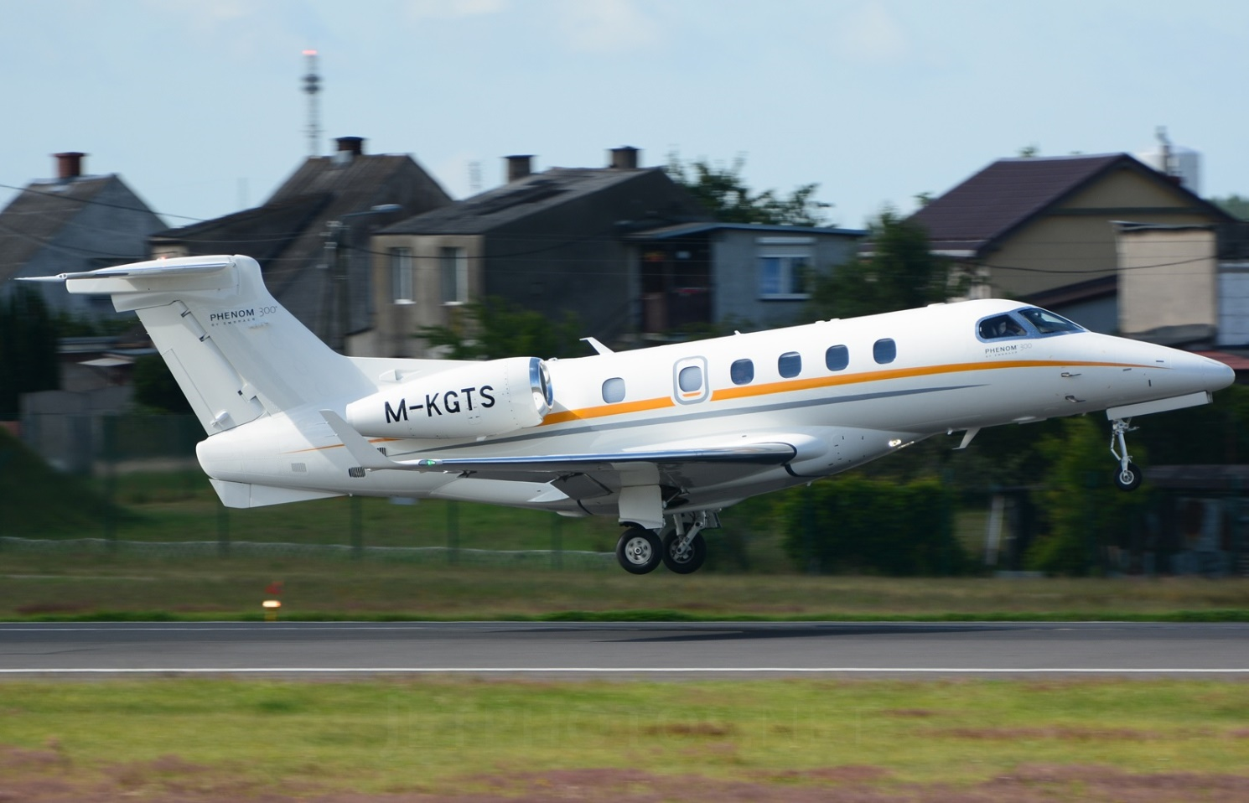

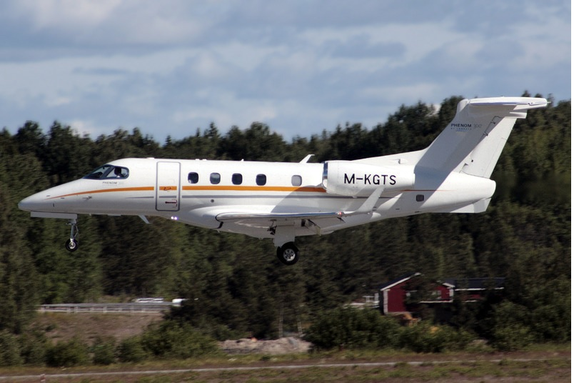

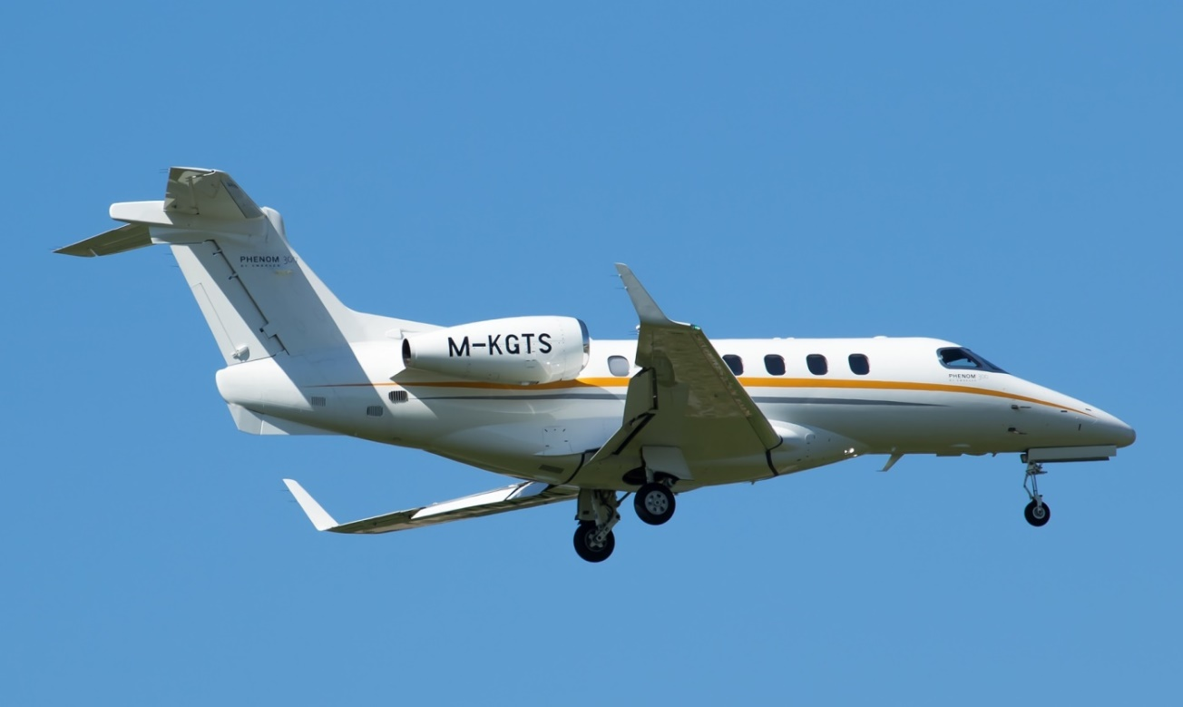

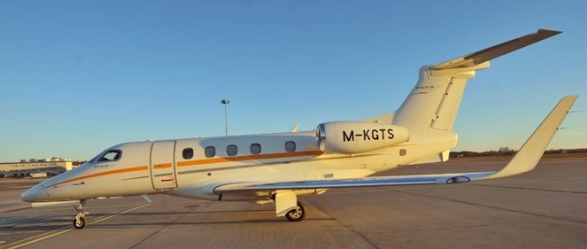

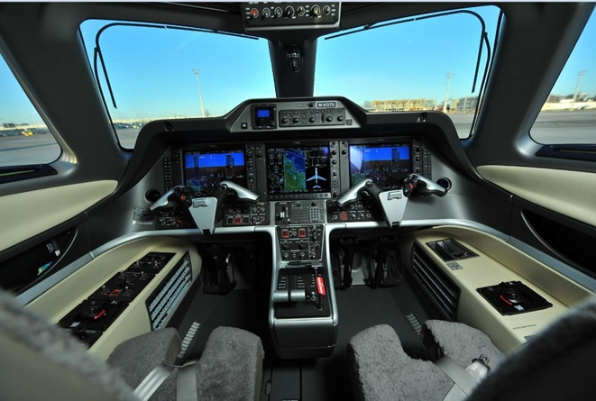
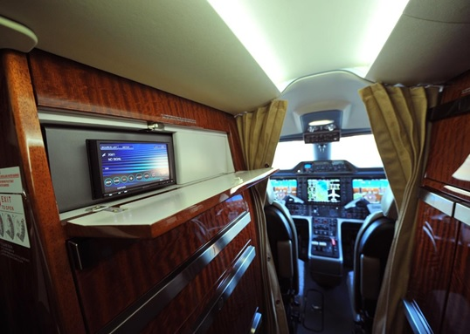

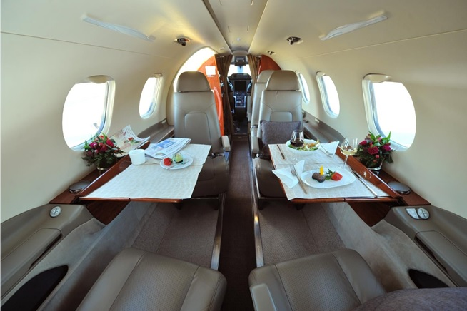
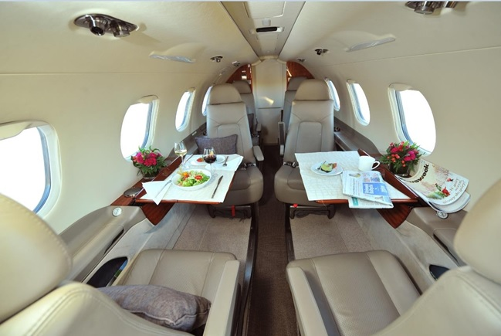
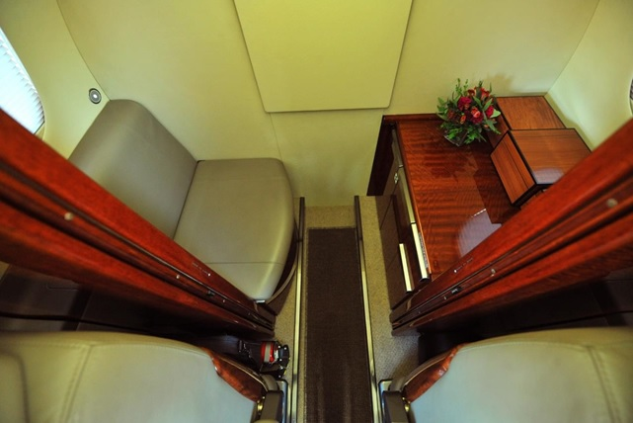

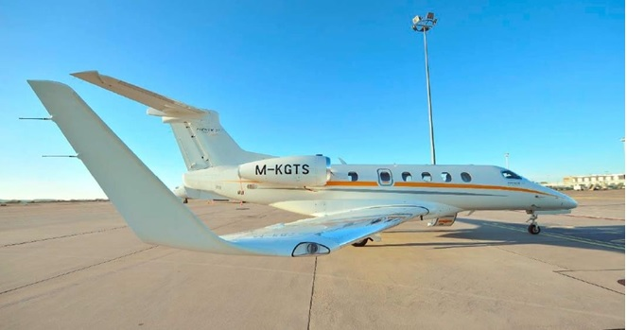

Specifications are Subject to Verification Upon Inspection and/or Prior Sale

