2002 KING AIR B200
Year | 2002
Manufacturer | Beechcraft
Model | King Air B200
Registration | EC-ILE
Serial Number | BB-1792
Location | Spain
Price | Make Offer
Total Time | 3,827 hrs
General Information
Low Time
One Operator Since new
VIP or Medevac Configured
Very Well Maintained
RNAV 5 Compliance
Always hangared
Times as of November 6, 2018
Airframe
3,826:55 hrs and 7,120 Landings
Engines 1 & 2
PWC PT6A-42
PCE-PJ0587: 3,694:05 hrs SMOH (TBO 3,600 hrs), 1,894:05 hrs Since HSI (Interval 1,800 hrs)
PCE-PJ0732: 855:50 hrs SMOH (TBO 3,600 hrs), 855:50 hrs Since HSI (Interval 1,800 hrs)
Props
Hartzell HC-E4N-3G
S/N HH1408: 927:25 hrs SPOH (TBO 4,000 hrs / 72 Months), Due Date May 2020
S/N HH915: 927:25 hrs SPOH (TBO 4,000 hrs / 72 Months), Due Date May 2020
Avionics
EFIS-84. Proline II (2-Tube).
Autopilot: Collins APS-65.
Flight Director: Collins APS-65 w/ EFIS EFD-84
GPS: Garmin 400
COMs: Dual Collins VHF-22C
NAVs: Dual Collins VIR-32
DME: Dual Collins DME-42
ADF: Collins ADF-60A
Radioaltimeter: Collins ALT-55B.
Weather Radar: Collins WXR-270.
Transponder: Dual Collins TDR-94
ELT: Artex C406-2. 406 MHz compliance
Equipment
Engine driven Air Conditioning System
Brake Deice System.
77 cu ft Composite Oxygen Bottle
965/2012 Equipped
EMS Electrical provisions. M11-011-24
EMS Equipment Rack. M12-054-25
Rear EMS Equipment Cabinet. M13-062-25
Exterior
Overall White with Blue and Grey stripes
Interior
EMS Cabin configuration: 4 club chairs + Stretcher Lifeport EMS equipment. STC EASA.IM.A.S.01445
or VIP Cabin configuration: 2 + 4 Club Chairs
Storage Cabinets, Tables, Fwd & Aft Cabin Divider
Maintenance
Next Phase (200 hrs / 12 Months): Remaining 16:35 hrs / 5 Feb 2019
Complete Phase Cycle ( 800 hrs / 24 Months): Remaining 616:35 hrs / 5 Feb 2020
12 Month Inspection Due Date 5 Feb 2019
24 Month Inspection Due Date 5 Feb 2020
Landing Gear Overhaul (72 Months) Due Date 30 May 2020
Flammable Hoses (72 Months) Due Date 27 June 2021
Brake Hoses (72 Months) Due Date 27 June 2021
Hyd Liquid Hoses (72 Months) Due Date 21 Jul 2021

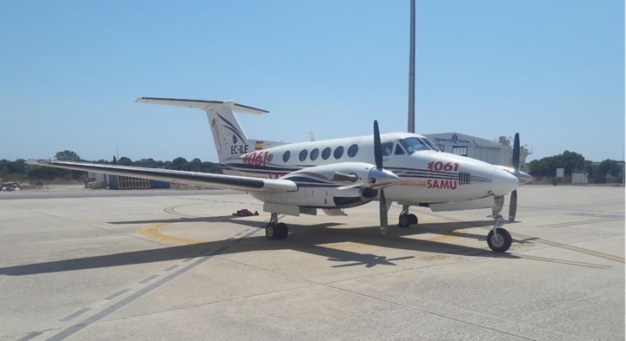

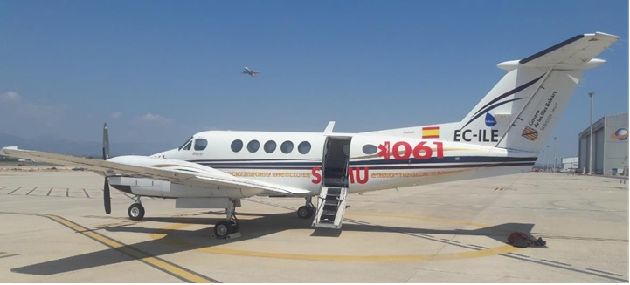

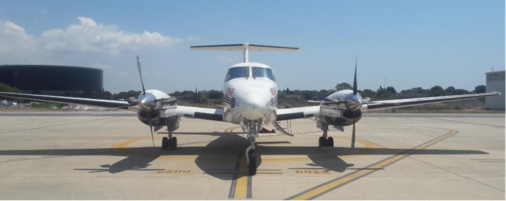

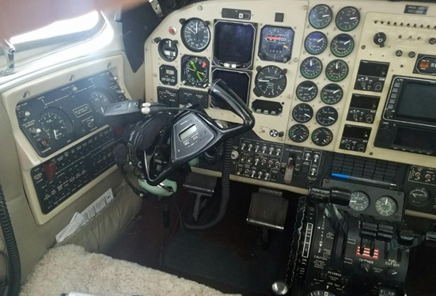

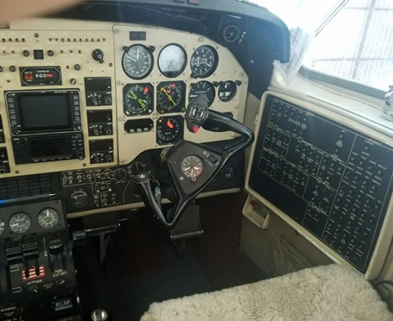
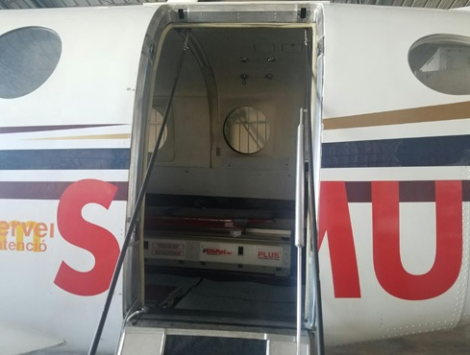

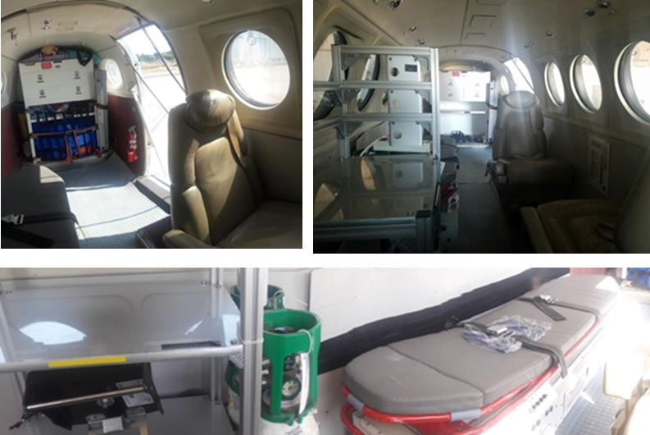

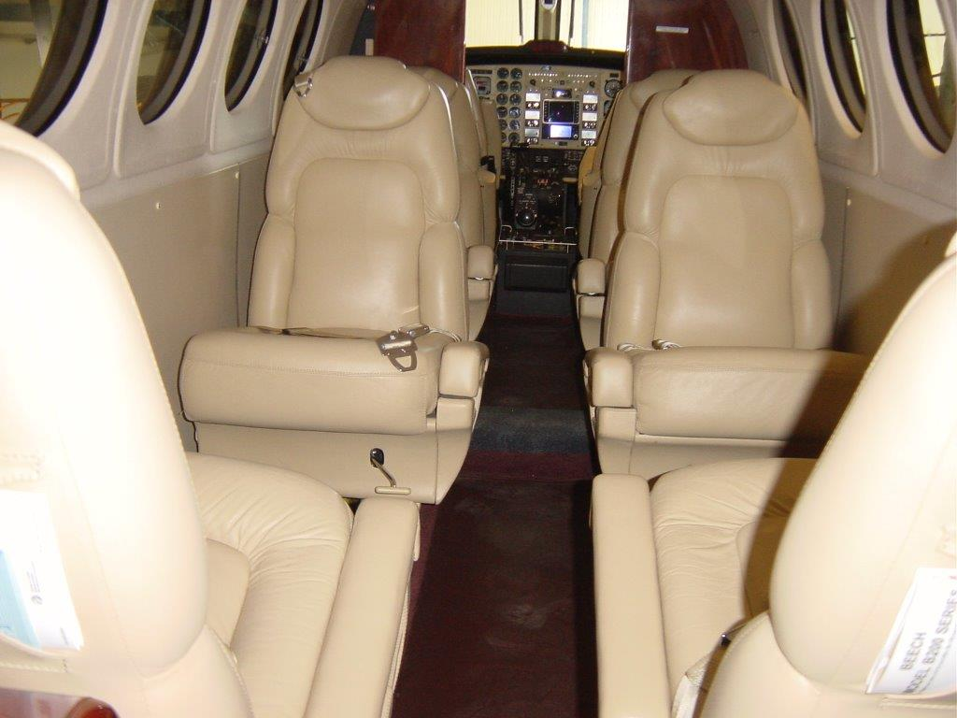

Specifications are Subject to Verification Upon Inspection and/or Prior Sale

