**2018 ROBINSON R66 MARINE**

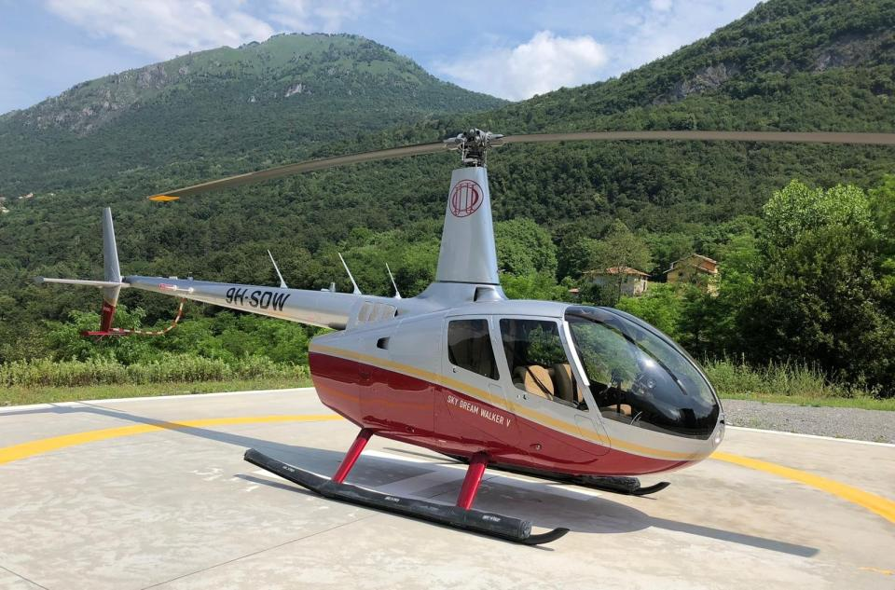

|  |  |
| --- | --- |
| Year | 2018 |
| Manufacturer | ROBINSON |
| Model | R66 |
| Price | Make Offer |
| Total Time | 300 hrs |
| Location | Europe |
|  |  |
| **General Information** |  |
| Pop Out Floats |  |
| Auxiliary Fuel Tank (43 US Gallons) |  |
| Air Conditioning System |  |
| SAS Autopilot with EFIS |  |
| Radar Altimeter |  |
| **General Information (continued)** | |
| PFD: Aspen EFD1000H Pro version (with HSI) | |
| Transponder, Garmin GTX 345 with ADS-B In & Out | |
| Bose Headsets A20 with Bluetooth x 5 |  |
| Bose Interface all seats |  |
| Battery, Lithium-ion TB17, 17 Amp Hour |  |
| No Damage History |  |
|  |  |
| **Airframe** |  |
| 300 hrs TT |  |
|  |  |
| **Engine** |  |
| RR 300 hrs TT |  |
|  |  |
| **Avionics** |  |
| SAS Autopilot with EFIS |  |
| Garmin GMA 350Hc Audio Panel |  |
| COM, Garmin GTR 225B with 15 Memory Channels, Cyclic Grip Control | |
| Transponder, Garmin GTX 345 with ADS-B In & Out | |
| GPS/COM/NAV: Garmin GTN 650 |  |
| PFD: Aspen EFD1000H Pro version (with HSI) | |
| Radar Altimeter: FreeFlight RA4500 |  |
| IVSI - Instantaneous Vertical Speed Indicator |  |
| GPS Fleet Tracking Spidertracks S6 |  |
| ELT: Kannad 406 Integra AF-406 MHz |  |
| Digital Chronometer: Davtron 800 |  |
|  |  |
| **Additional Equipment** |  |
| Pop Out Floats |  |
| Auxiliary Fuel Tank (43 US Gallons) |  |
| Air Conditioning System |  |
| Heated Pitot |  |
| Halon Fire Extinguisher |  |
| Battery, Lithium-ion TB17, 17 Amp Hour |  |
|  |  |
| **Exterior** |  |
| 2018 |  |
| Extra Corrosion Protection |  |
|  |  |
| **Interior** |  |
| 2018 - Bose Interface all seats |  |
| Bose Headsets A20 with Bluetooth x 5 |  |

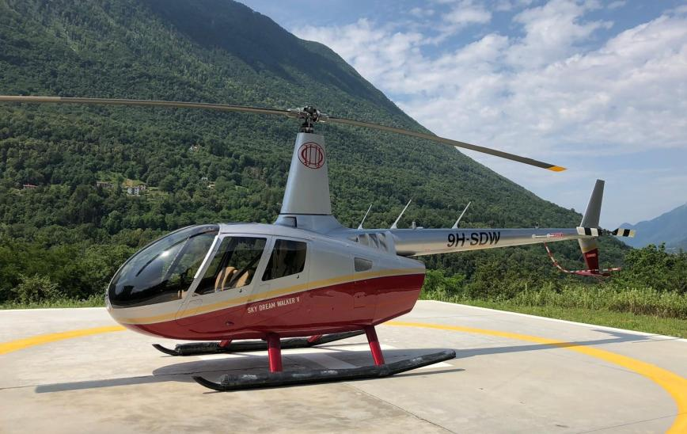

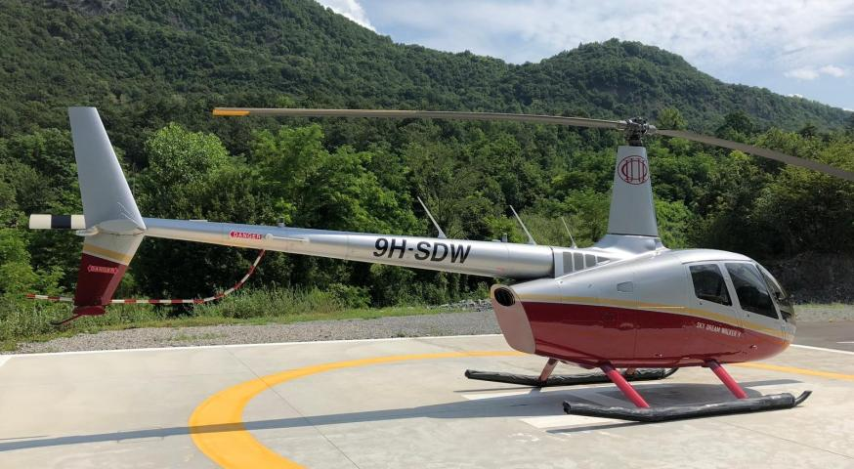

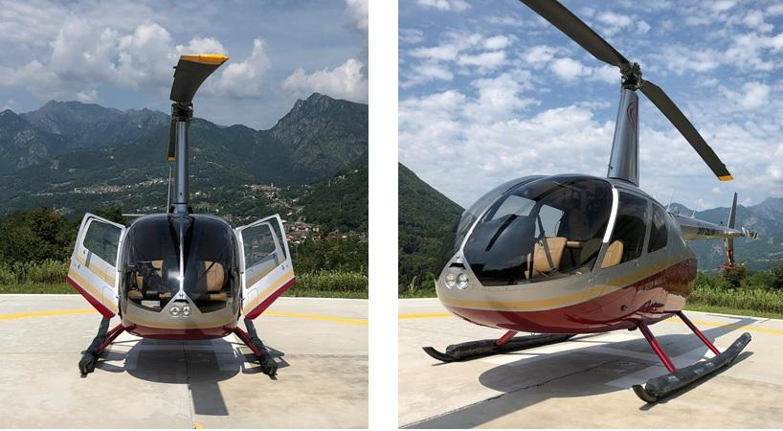

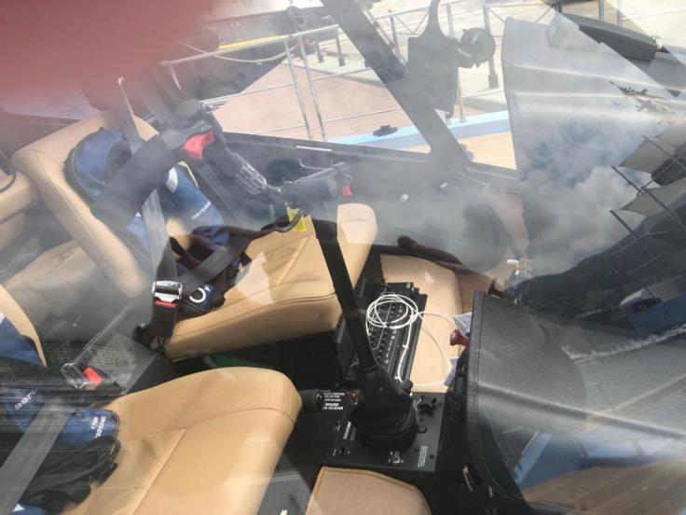

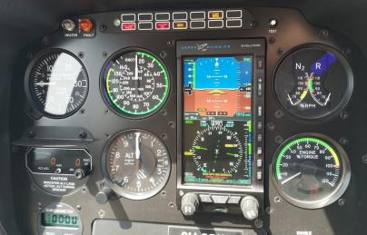

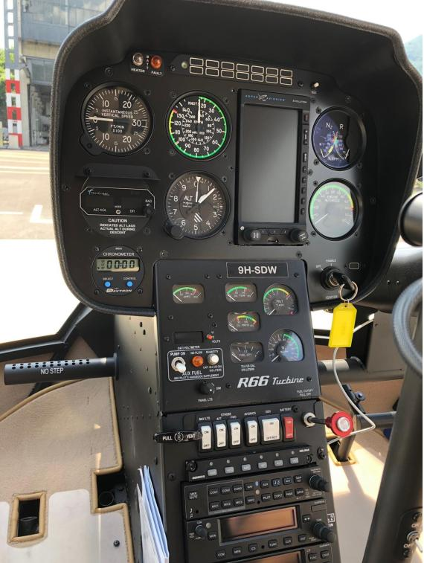

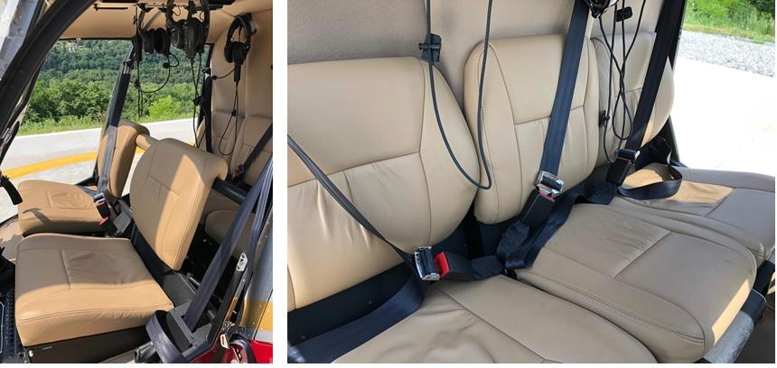

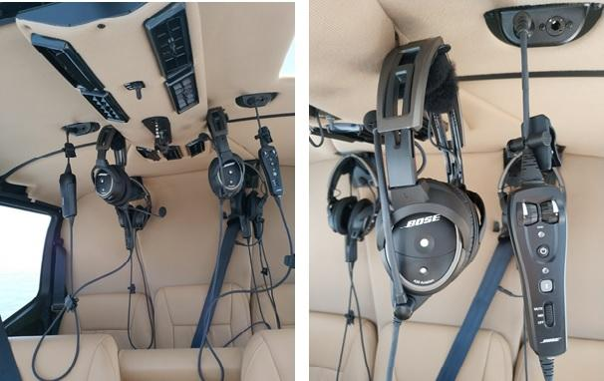

Specifications are Subject to Verification Upon Inspection and/or Prior Sale