1988 KING AIR B200C

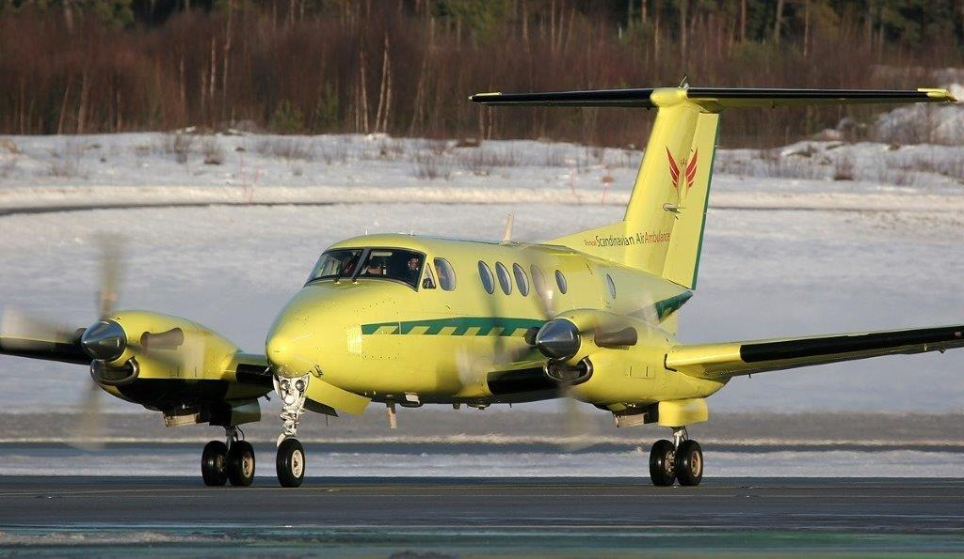

General Information
Medevac Configured
Very Well Maintained
Factory Cargo Door
Raisbeck 4 Blade Props
High Floatation Landing Gear
AFT Air Conditioning
Raisbeck Gear Doors
Raisbeck AFT Body Strakes
Freon (R134) Air Conditioning
Raisbeck Enhanced Leading Edges
Raisbeck Ram Air Recovery

Registration |  | SE-KFP
Serial Number |  | BL-132
Location |  | Europe
Price |  | Make Offer
Total Time |  | 20,299 hrs
As of May 30, 2017
Airframe
20,299 hrs, 24,532 Cycles
Engines 1 & 2
PWC PT6A-42
Left: 3,209 hrs SMOH, 328 hrs Since HSI (extended TBO 7,000 hrs)
Right: 5,741 hrs SMOH, 111 hrs Since HSI (extended TBO 7,000 hrs)
Props
Hartzell HC-D4N-3A
Left: 1,730 hrs SPOH, Due Date 2021, TBO 4,000 hrs
Right: 2,853 hrs SPOH, Due Date 2022, TBO 4,000 hrs
Avionics
Auto Pilot: Collins APS-65
Flight Director: Collins APS-65 w/ EFIS EFD-74.
Radar Altimeter: Collins ALT-50
COMs: Dual Collins VHF-22C
NAVs: Dual Collins VIR-32
DME: Dual Collins DME-42
ADF: Collins ADF-60A
GPS: Trimble 2101
Weather Radar: Collins WXT-250
Transponder: Dual Collins TDR-94D
Equipment
Factory Cargo Door
Raisbeck 4 Blade Props
High Floatation Landing Gear
AFT Air Conditioning
Raisbeck Gear Doors
Raisbeck AFT Body Strakes
Freon (R134) Air Conditioning
Raisbeck Enhanced Leading Edges
Raisbeck Ram Air Recovery
Exterior
Overall Yellow with Green stripes, Standard EU ambulance Color.
Interior
Lifeport Ambulance Interior
Dual Tandem System STC SA4745NM / SA00183WI
2ea Stretchers and Overhead Serviplex
3 Chair Cabin Configuration
Maintenance
Landing Gear Due 3/2018
Wing Bolt 5 Yr. Inspection Due 2/2019

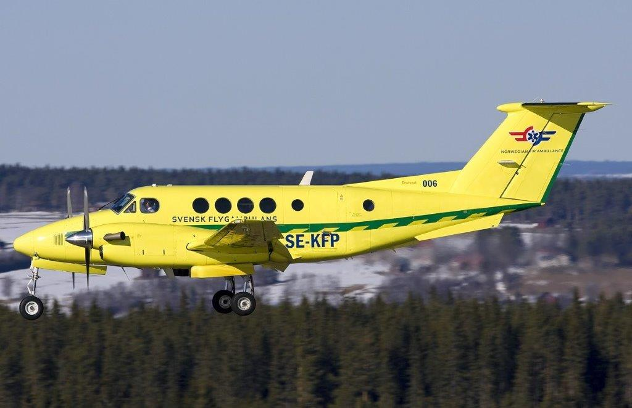

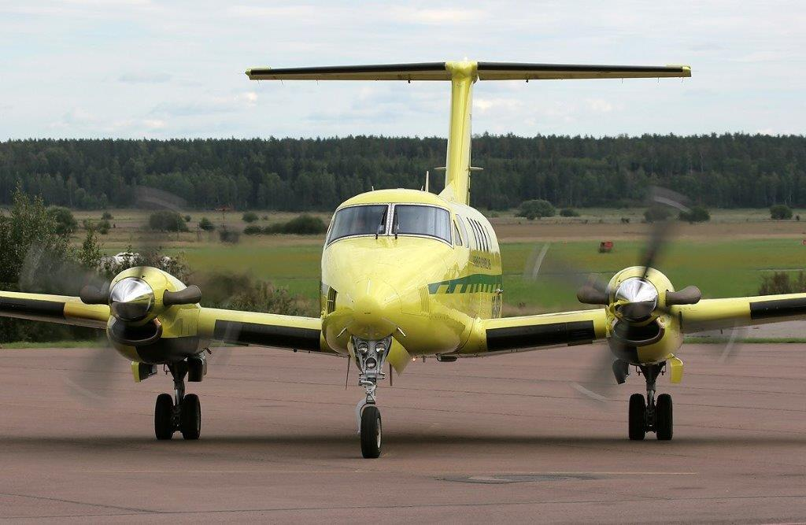

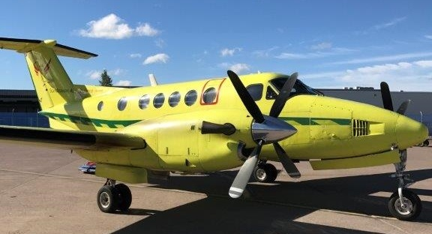

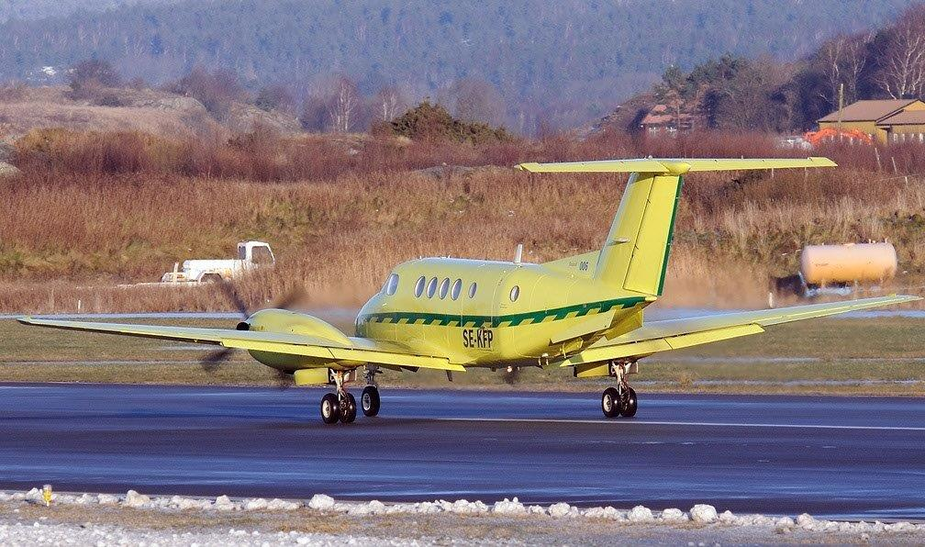

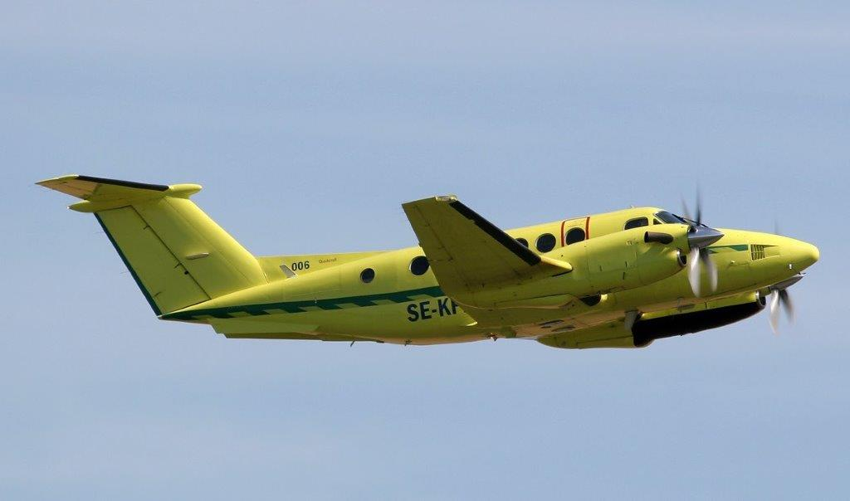

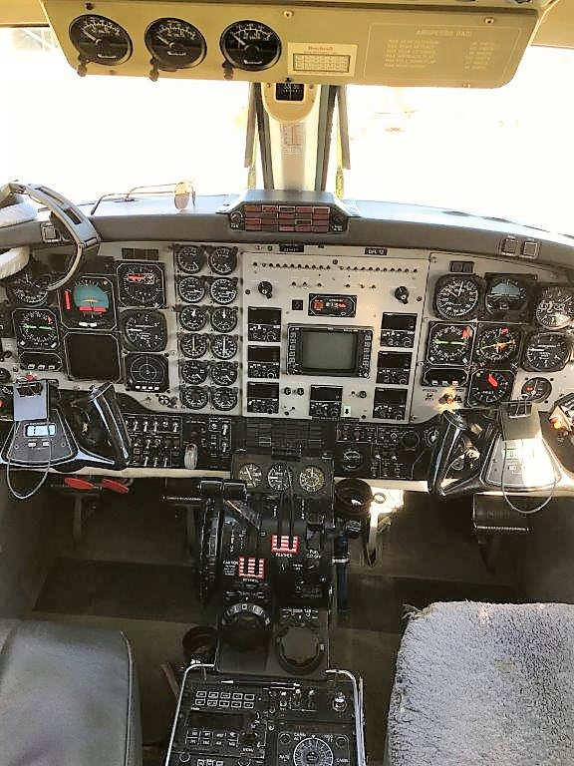

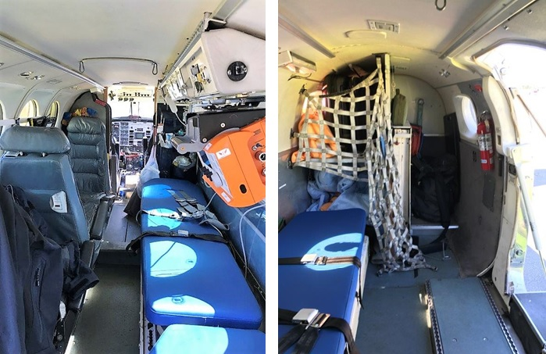

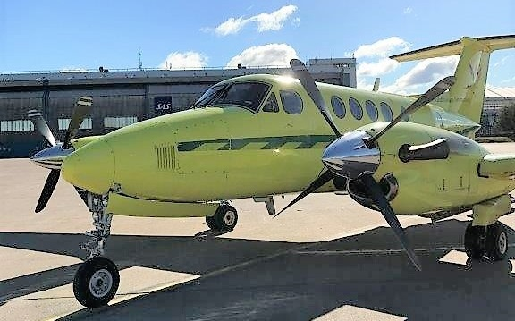

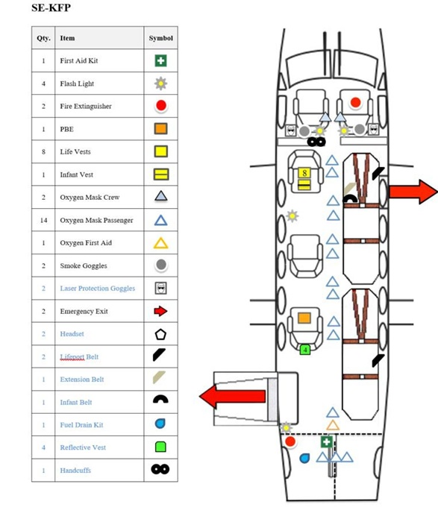

Specifications are Subject to Verification Upon Inspection and/or Prior Sale

